


BLUEROSE PUBLISHERS
India | U.K.

Copyright © Mayaank B 2025

All rights reserved by author. No part of this publication may be reproduced, stored in a retrieval system or transmitted in any form or by any means, electronic, mechanical, photocopying, recording or otherwise, without the prior permission of the author. Although every precaution has been taken to verify the accuracy of the information contained herein, the publisher assumes no responsibility for any errors or omissions. No liability is assumed for damages that may result from the use of information contained within.

BlueRose Publishers takes no responsibility for any damages, losses, or liabilities that may arise from the use or misuse of the information, products, or services provided in this publication.



For permissions requests or inquiries regarding this publication,
please contact:

BLUEROSE PUBLISHERS
www.BlueRoseONE.com
info@bluerosepublishers.com
+91 8882 898 898
+4407342408967

ISBN: 978-93-7139-245-7

Cover design: Yash Singhal
Typesetting: Namrata Saini

First Edition: November 2025

Contents
Preface iv
- The Haunted Villa 1
- The Knock on The Door 9
- The Mysteries with the Demon 16
- The Whispering House 25
- Eyes That Eat Universes 35

Preface
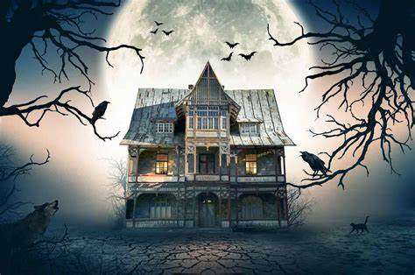
There are many stories about the horror if we list them out it will take years to select one but this one is the most horror from all of them (I hope). This story is about a place called Drazulia. There are many stories about this place. Some of them are in this book. This book is for people who are obsessed over reading horror books. I got the idea of writing horror books because they have the ability to fill anxiety in me, like if there is any creature in the chapter then I will be having that anxiety about what happened to the people and what the creature or monster did or did it harm the people.

1

The Haunted Villa
This was about a time, long, long, long ago. In a small place called Drazulia. A Family couldn’t afford rich privileges like other families, they used to live in a small house which was surrounded by long, dense grass. They thought they could survive in that house long enough but until the land lord came and gave an eviction notice. They have to leave the house in 24 hours. They were heartbroken and didn’t know what to say about this to their kids. They told their kids that they had to leave the house but, the kids said “ we don’t want to leave please, can we stay for just one more day”, suddenly they got a call from the land lord, he said” I have a villa for sale if you want it you can have it because anyway no one is buying it and it is not even that costly it is just ₹90 per month”, When they heard it they were so happy and immediately they packed their luggage, baggage and left the next moment they heard the news. They did not know what was coming up. When they came to the Villa they observed that it was very tall, wide and enough for them to survive forever. As soon as they were about to open the doors, the doors opened on themselves like as if they were welcoming the the family with a loud creaking noise. They were a little nervous about entering the house because it was abnormal but they had no other choice. They started unpacking their luggage, the furniture in the house and suddenly they found a bloodstain under the doormat The mother was horrified and disgusted at the same time she called her husband and, asked him “ why is a bloodstain here “, her husband was also horrified, he brought the mop stick and starting rubbing it very hardly but it did not come off no matter how hard he rubbed and finally he gave up. The wife told her husband “ we need some groceries, detergent powders and equipment for cleaning the house”, the husband took two bags and started his way to the market. The mother called the kids and told them help her in the kitchen and unpacking work, when the kids came down they asked her mom “mom can we have a tour of the villa because its very big and it has many rooms, we can even choose our rooms “ then the mother replied ,”sure I don’t see why not go have fun choosing your rooms”, the kids went upstairs and while they were going upstairs they noticed that a picture on the wall was moving very much, they were very excited and scared at the same time so they removed the picture and there was a small hidden room, they were horrified and called their mom,
2
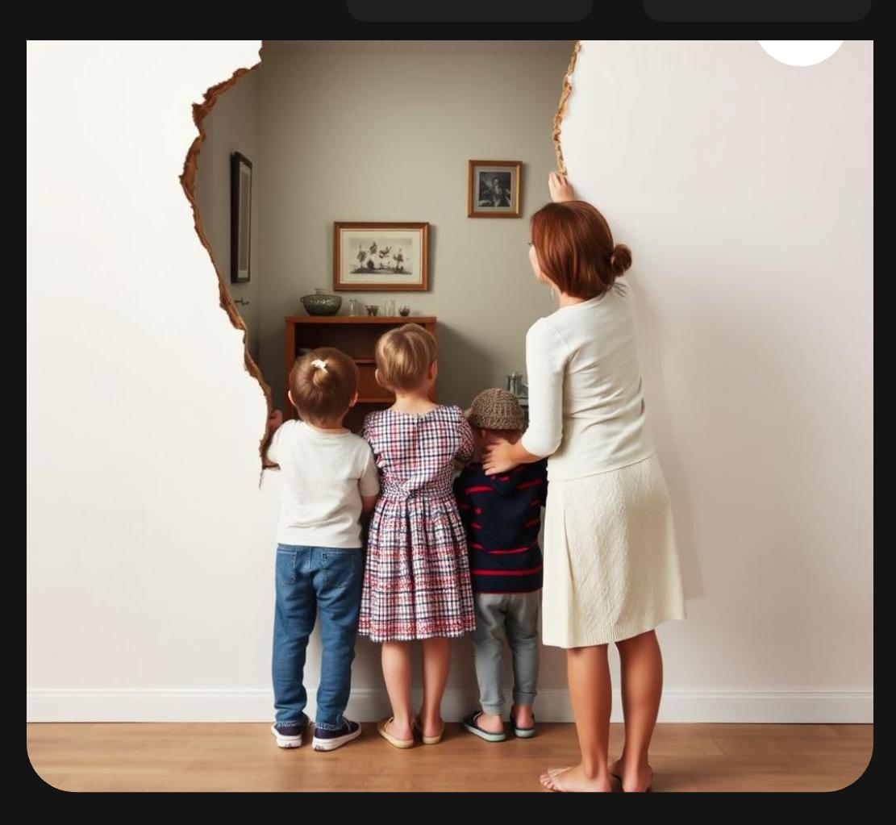
she came and asked “ why did you call me, you can choose your own rooms right or do you want me choose them for you” , then the kids replied “ no that’s not the problem, the problem is that there is a hidden cabinet behind this picture “, the mother did not believe them and thought to herself that how could a cabinet be behind a picture, she removed the picture and she was shocked ,she said “ you guys stay right here I’ll go check if there is something that is not safe” , when the mother went inside she did not come out for almost an hour the kids got scared and they called his father and their father did not respond so that’s why the children thought of going inside to check what had happened to their mother, when they went inside they saw their mother being pushed against the wall by an unseen force they got so scared, and did not know what to do suddenly the door bell rang and everything came back to normal the mother fell down on the floor, when the kids opened the door there was no one except a shadow of an unknown creature it had big ears, strong muscles with a lot of hair The kids slammed the door and ran to their bedroom and covered themselves in the blanket they heard footsteps coming upstairs, they clung to each other very tightly. They saw the same shadow coming closer and closer to their room. Then suddenly her father came and asked “why are you guys wrapped inside the blanket like a burrito”, Then the kids replied “There was a big shadow with big ears, strong muscles and a lot of hair”
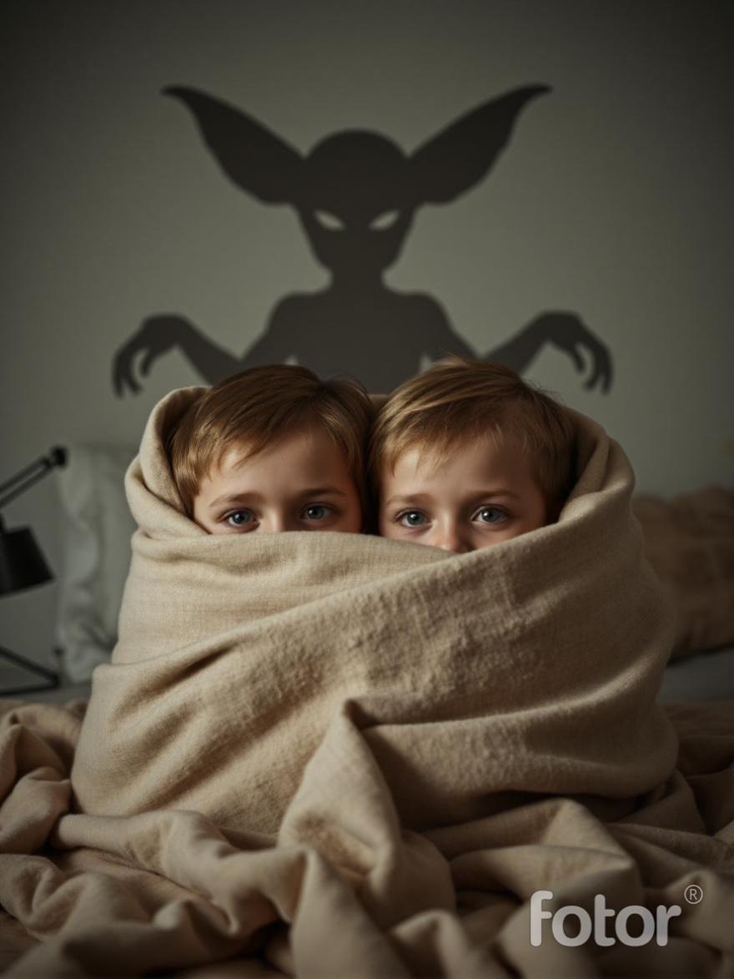
The father left the room with a small giggle. The kids started getting suspicious because their father didn’t answer the call when the kids called him but now he came to the house so fast. The kids thought of going to bed because after such a meaningless situation and after seeing their mother that kind of situation they did not want to ask her to prepare dinner. They still did not understand what is happening, how their mom was pushed against the wall, how a bloodstain appeared on the floor, how their dad came back from the market so fast, and how the doors of the villa opened by themselves. They were so confused, but they thought of finding the answer to their questions tomorrow. The next day when they got up their parents were not to be seen anywhere in the house both of them were home alone so they just cooked themselves some mac n’ cheese and started studying Suddenly they got a call from their neighbors on the telephone they were panting one of them told the neighbors to cool down then the neighbors told “ two strange creatures were following us and that is why we hid inside the cupboard “ and then the kids asked the neighbors how those two creatures looked like and surprisingly the neighbors told the same attributes as the creature which the children they had seen yesterday night. First of all the kids told the neighbors to come to their house, after the neighbors came, the children had set a trap to catch the creatures. after some time the two creatures were suddenly caught in the trap and then they went to look at the two monsters they were really gigantic actually it was really because they suddenly merged to form a three-headed monster which was a little scary and funny.
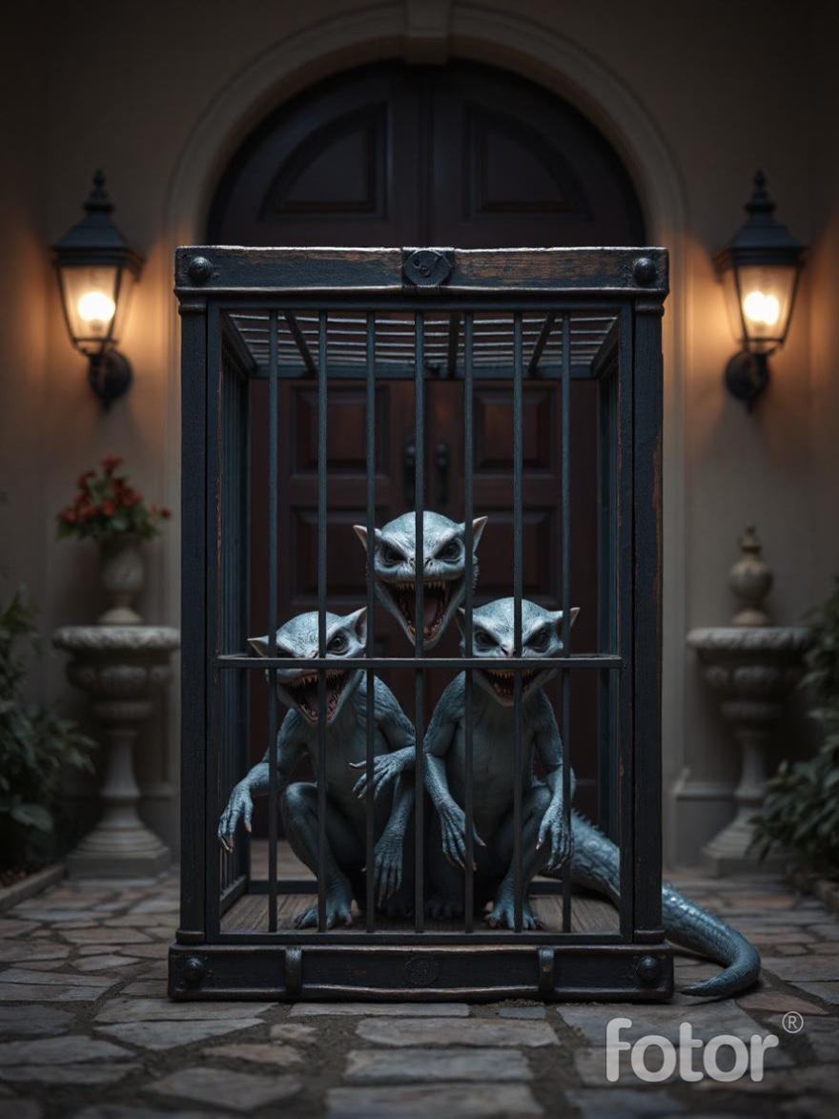
they tied the cage to their neighbors car and drove to a church and found out this monster was none other than their parents the two children were shocked and then the father of the church chanted some spells and threw holy water on them they immediately changed into normal humans and the priest of the church gave both the parents two necklaces with will prevent them from transforming them into a monster again so they thought that the mystery had been solved but again during the late evening the mother went to take bath to get rid of all the negative thoughts and then she removed the necklace which the priest of the church had given her and as soon she got out of the bathroom she forgot about the keychain and while she was drying her hair she by mistakenly hit the necklace into the sink she started to become worried what was going to happen to her she ate dinner and everyone slept but the mother used to get up in the middle of the night and act very weird like roaming around in the room, banging the door with her head, scratching the door, the father and the children asked the mom what happened to her the mother said “I don’t remember anything what did I do” the children told her mom what had happened and then was frightened, so the father divided his necklace in half and tied it around the wife’s neck and suddenly the wife felt like someone passed through her body (she thought it was weird ) , all of them went to sleep. The next morning they all woke up with a fresh mood and they proceeded with their daily works and finally after all of them were ready to sleep the wife took three candles around her for safety so that none of the negative powers can summon her but in the midnight due to the wind the candles got blown away. And the necklace in the mother’s neck fell down automatically and then she was possessed she started doing the same thing as yesterday the father got worried about her so he took her to the church again, this time the priest of the church wasn’t there the helpers sprinkled some holy water on her so that the devil or demon will have no choice but to exit her body then she felt very better and happy because she was cured. the helpers told “this problem has been solved and there is no need to worry now so you and your wife can remove the necklace stay freely”
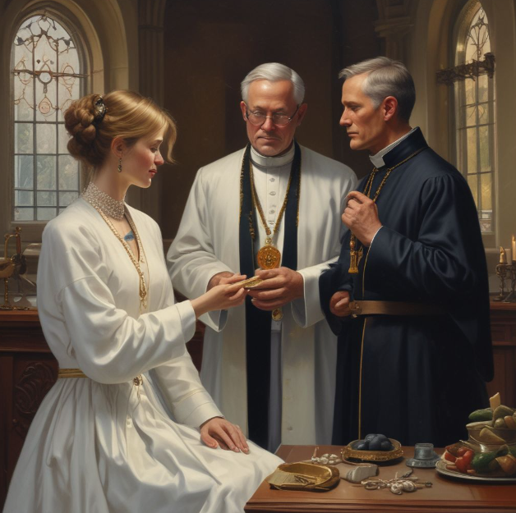

2

The Knock on The Door
One day a family left their kids in the house and went for a vacation and they left all the essentials to eat and they appointed a babysitter to care of the children. The children were quiet mysterious kids they used prank every babysitter who comes to their house to babysit them this time they took it too far they thought of pranking the babysitter by being in a disguise of a clown and scare her and when they went in they got dressed and on the count of three they both came out and scared the babysitter, she fainted and fell down because of the shock. The kids were scared and called her trying to wake her up but then she woke up and said “Pranked you” the kids became frightened and three of them started laughing suddenly someone knocked on the door the time was 11:30 in the night and who could it be, the babysitter told the kids to stay there only and the babysitter went see who it is she saw through the peephole she gasped and fell the ground when the kids came and asked her what happened she said nothing then the kids went to the peephole and saw what it was, there was nothing then the babysitter told not to open the door but the kids did not listen and opened the door but to her surprise there was nothing the babysitter checked both the sides, there was nothing when the kids asked “ what did you see the through the peephole “ then the babysitter explained “ there was like a doll’s face it was red face, full white eyes and a bloody mouth it was so scary,
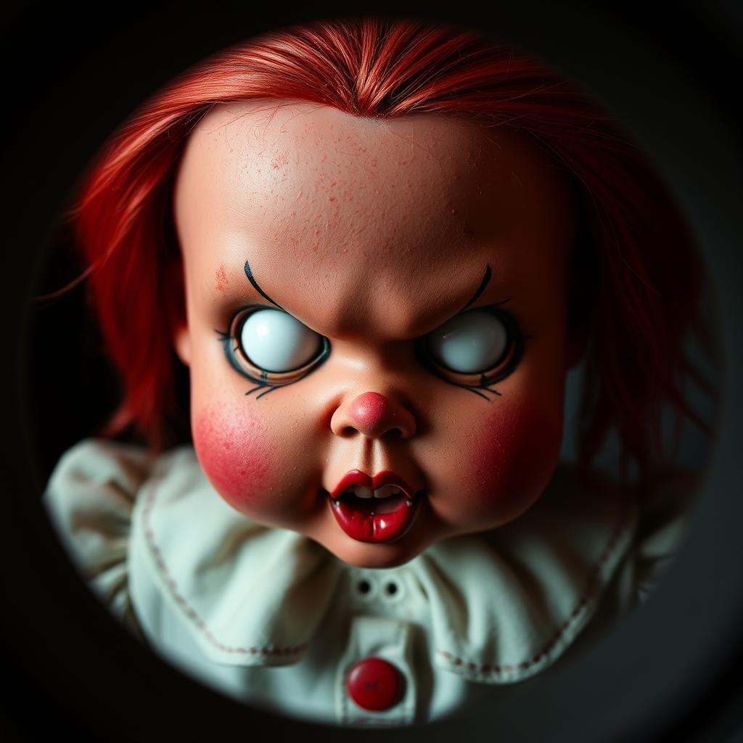
“then the kids and the babysitter went back to the room and again someone knocked on the door, three of them opened the door and there was a note saying ‘I can see you’ they got confused the kids said “ who can see us we are inside the house and there is no window or door open to take see us “ then three of them took a chair and sat near the door this time no one knocked on the door the babysitter went to the kitchen to get some food to eat then the babysitter shouted “ aah” then the kids went to the kitchen and saw that she was lying down on the floor they saw black footprints leading to their bedroom, when they went to the bedroom everything was messed up the windows were open, the bedsheets were ripped, the cupboards were open, the clothes were lying on the floor. The kids became scared and they went to the kitchen to check on the babysitter they woke her up and gave her some water to drink then she said “ there was a man with the same doll face and he pushed me to the cupboard, the box fell on me and I fainted “ the kids told the babysitter “we will go and lock all the doors and come you stay right here” the kids went to the bedroom, cleaned it up, locked the window and they went to the kitchen to call the babysitter to come and sleep. They all went to sleep it was 1:00 am everything was silent until someone knocked on the door again. The babysitter opened the door and went outside the house to check and suddenly the lights went off, the door shut close, the babysitter ran to the door and started banging on the door. Then she heard footsteps coming upstairs to her floor, she got frightened and started running to the elevator to go down but as soon she went inside and the elevator door closed the lights in it started flickering the elevator started shaking rigidly and the elevator stopped in the same floor the doors opened she came out and saw everywhere there was no one and she rang the doorbell the kids woke up and

opened the door and the kids asked “what are you doing outside at this time” then the babysitter said “you guys come in I will explain you later first call your parents” then the kids took the babysitter’s mobile and called their parents but they were not answering the call. So the babysitter was scared. Now she did not know what to do, everything was very intense and scary she just hoped the children’s parents returned home as soon as possible. She asked the children “ until and unless it is morning we all have to sleep here in the living room, are you kids okay with it?”, then the kids replied “ yeah we are absolutely okay with it, it is more cozy for us in the couch than in the bed” the babysitter wore her night pajamas and all of them were ready to sleep and this time the babysitter thought that she will put flour on the floor from the stairs to their house so that she can track the footsteps and as usual when someone knocked on the door this time the babysitter thought that the culprit would be caught and after sometime she checked outside the house to her surprise she caught the footsteps she tracked the footsteps and they led her to the basement of the apartment she was a little scared to go there but she thought it was her job and when she came inside the basement the footsteps stopped near the entrance, she searched in the basement to find for any evidence but then she saw that there were so many shoes inside the basement she was confused and scared about the shoes what they had to resemble and suddenly she heard a cardboard box fall down she saw that there was a very huge gigantic scary yeti she ran out of the basement to the house and locked the door she saw through the peephole and saw that the yeti again knocked on the door this time he did not carry his doll with him and he even knocked on the door very hard that the imprints were visible she told the kids to hide under the bed, the babysitter went behind the curtains and hid, when the yeti came inside the house, he was searching for the three, then he entered the room where they were hiding, three of them tried their best to be as silent as possible but then one of the kid sneezed the yeti heard the sound and bent down and saw the children, the yeti stretched out his hand to grab the children and suddenly the babysitter took a toy of the kids behind the curtain and
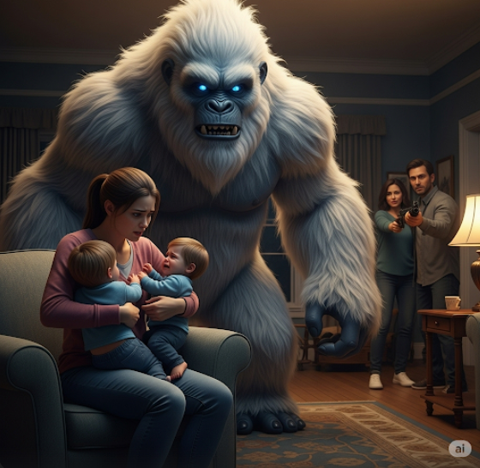
threw it on the yeti to distract him then the children ran away and shouted “catch us if you can yeti” the yeti ran behind the children, all things in the house started falling because of his weight and then the babysitter and they all ran around the house finally they got cornered by the yeti they were scared the babysitter stepped front to save the children she thought to herself “I have only few more years to live but these children still have their whole life ahead, I will fight for them” and suddenly when the yeti was about to grab the babysitter the parents shot the yeti with a gun and the yeti immediately collapsed on the floor collapsed on the floor.

3

The Mysteries with the Demon
One day Paul a 13-year-old teenage boy was invited to a boys’ night out to his friends’ house. Their houses were 13 kilometers away from each other and a dense forest had to be passed to reach each other’s’ house. Paul was an adopted child because his parents had died at his birth. That day he was spending the day with his foster parents so he had no time to visit the boys night out but his friends were reluctantly asking him to come so he could not resist and he had another problem his parents were long asleep and he could not ask them to drop him so he did the thing which any spoilt kid would do, he snuck out of the house and walked his way to his friends’ house but on his way to his friends’ house he met an old man near the entrance of the forest holding a sign that said “no entry without torch” he thought to himself “why do we need a torch is this some kind of haunted and spooky forest” and he giggled then the old man said “son, you do not have any idea how many people have lost their lives in this scary forest and that is why do not make fun. People think the souls of the people who have lost their lives in this forest are still roaming around here” then Paul asked him “How do you manage to survive here, don’t you get scared? “ the old man replied “Oh dear son I am very old and have no interest in living this life and especially when my wife lost her life here I started guarding the forest so that no one enters it lose their lives” the boy asked him “why have people lost their lives here? “ then the old man replied “whenever someone entered the forest, they would here someone calling their name from the back, they would get scared and start running faster to get out of the forest but then they would again here their name but this time with a sweet voice making it tempting to look back but they did not know that there was a very deadly monster waiting for them to look back and you know what it will do, also another thing no one ever knew why they disappeared. Some people would look back at the first call and some people would look back in the second call but some people would turn back at the third call which is said to be a known person’s voice and people believe no one had ever resisted from looking back at the third call.” after hearing this story Paul got scared to enter the forest then the old man added “if you really have to get through the forest then take this torch and remember to not look back” he handed over the torch. The boy entered the forest and then he felt cold breezes he heard owls howling he started getting goosebumps after seeing the forest there was a very stinging smell he almost threw up. Then suddenly the unexpected happened, Paul heard a voice behind saying “ Hi Paul” it was a soft female voice, he remembered the warning of the old man and kept walking then he heard another voice “Hi Paul” but in a sweeter voice but the third voice sounded like his mom’s, then he could not resist and he turned back and he did not see anybody so he started seeing around him he did not see anything but when he started walking he saw a fat and ugly monster standing in front of him. He immediately turned back he saw another one then every side where he turned, he saw one and he was surrounded them, he got scared and did not expect anything to happen. Without any hope he kneeled and closed his eyes and ears expecting the worst to happen then he suddenly saw that the monsters gathered into one body, kneeled and kept a hand on his shoulder and said “I am really sorry I did not mean to scare you, please open your eyes” then he wondered why the monster kept a hand on his shoulder and opened his ears and to his surprise he saw the monster looking at him with a sad face then the boy asked “what happened ?” then the monster replied “I was never like this, I was a handsome young man my name is Ryan I always used to showoff my handsomeness until one day I was passing through a house which had a big lawn and had a sign “do not enter” but I did not care and when i stepped on the lawn, nothing happened but then an old man stepped out of the house and turns out he was a well versed priest who had been resting, he had actually kept that board because he was annoyed when things were being thrown at his lawn like stones but still no body cared about the sign and one day a boy’s football fell in the lawn then the old man came out with an angry face, he took the ball, deflated it and threw it at the boy’s face and people stopped throwing stuff at his lawn as I did not know this I stepped on the lawn and thought why would anyone scold me I am very handsome and the priest cursed me to become an ugly monster and vanish anyone I see in the forest nearby and this was the forest nearby” then he said “then how can you be set free from this curse because you cannot live like this forever, you will have your own life” the monster replied “no one can but only the father himself can do it he has to forgive me which he will never do” then he told “it’s ok, you and I both will talk to him about this curse and get it resolved” the monster started crying, then the boy asked him “why are you crying”, the monster replied sobbingly, “no one had ever tried to talk to me except you” then the boy interrupted “weren’t you the one who tried to speak to me?” then the monster replied “yeah, but I tried to talk to everyone, but all of them were no hope they just tried to run away and then I used to get angry and vanish them” the boy said “you have to reduce your anger” then he agreed and they started their journey towards the priest and in the middle of their way the monster saw the priest then he pulled Paul towards the priest who was walking to his home and he whispered in Paul’s ears “this is the priest I was cursed by” then Paul started a conversation with him and after sometime he came straight to the topic about Ryan, the priest immediately got fierce and shouted “don’t you dare talk about him, he is not what you think, did he tell you that I cursed him because kids used to irritate me ?” then the boy said “yes he did tell me something like that” the priest said “I know he would do something like that” and as soon as the two of them turned towards the demon who is no more Ryan he was in the form of a big demon smashing all the houses. Paul hid behind the priest and the priest took out his spell book to find a spell which can control unholy creature but then before he could read out the spells, the demon grabbed him by his neck, lifted him up and threw him aside, the priest had thrown a cross and spell book Paul picked them up and carefully looked at them and suddenly he spotted a script on how it is used, he read them and tried a spell on the demon it immediately fell down.
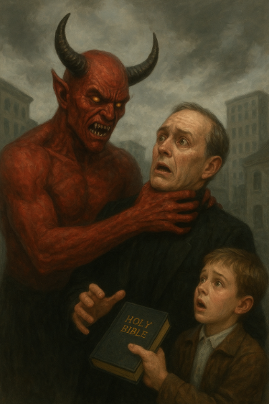
The boy felt proud about the powers he had. He thought to himself “this whole time the creature has been scolding me but now since I know the truth I shall end him” then the boy immediately tried all the spells on him and then the demon became angry and snatched the spell book away from Paul and tore it into half. The boy did not know what to do then he remembered that in the script of its usage, it was written that the cross was one of his weaknesses as it was made by the holy blood of the god himself, the boy immediately threw the cross at him but nothing happened, the demon laughed when the cross hit him. “Did you really think that would stop me?” he said in a deep, scary voice. Paul felt fear rise inside him. He had no spells, no book, and now the cross didn’t work either. He stepped back, shaking, his hands cold with sweat. But then he remembered something else from the spell book — a small line that said, “Only the brave heart of the chosen one can unlock the true power.” Paul looked at his hands. He thought about everything he had been through — the scolding, the fear, the pain. He thought about the people he wanted to protect. His heart felt strong, even if his body was weak. He took a deep breath and shouted, “I am not afraid of you!” suddenly, the broken pieces of the spell book started to glow. They lifted off the ground, spinning in the air. The demon looked confused and stepped back. Paul reached out his hand, and the pages flew to him, joining back together like magic. A bright light filled the air. The demon screamed, covering his eyes. Paul opened the book and read a spell he had never seen before. The words came to him easily, as if they were written just for him. As he spoke, the air around him grew warm and full of power. Then, a beam of light shot from the book and hit the demon right in the chest. The creature roared in pain and started to fade. Paul kept reading, louder and stronger, until the demon let out one final scream and vanished into thin air. Silence everywhere. The book gently closed in Paul’s hands. He had won — not just with magic, but with courage.
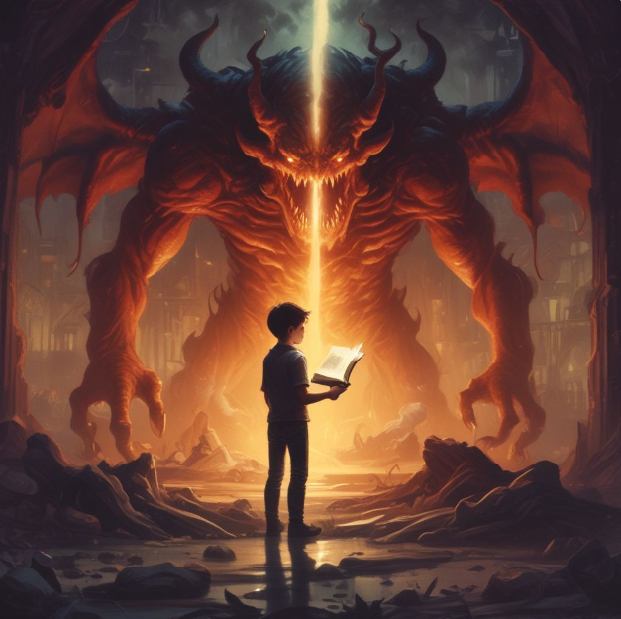
Paul looked around the quiet room. The air felt calm now, and the dark clouds outside the window were starting to clear. Light came in through the cracks, warm and soft. He slowly walked to where the demon had stood. There was nothing left but a small black mark on the floor. Paul held the spell book close to his chest. It was quiet again, no voices, no shouting. He took a deep breath and felt his heart slow down. He was still shaking a little, but inside, he felt proud. He had faced his fear. He didn’t run away. He stood strong. Then he thought about what had just happened. “Was that really me?” he whispered to himself. “Did I really beat that monster?” He smiled a little. “I guess I did.” Paul remembered about the priest he went and helped the priest get up who was in shock about what had just happened then the priest asked the boy “what did you just do? I thought you were just a normal boy who did not know anything about these spells” then the boy replied “yes sir, I was also surprised about what I had just did but it was all your wit and knowledge that saved us today because without your spell book no one would have saved me today, so I should be thanking you” the priest told “you are a brave, kind, selflessness, young man, you can always come to me at the time of danger or perhaps you can even join in my academy where simple people are taught to fight back against anyone” then the boy replied “I would love to do that” the priest simply handed over the location and left with a small smile on his face”

4

The Whispering House
It was a cold evening when Ravi first saw the house. He had never been to this part of the village before. The trees were tall and dark. The wind made strange sounds in the leaves. His bike’s wheels crunched over the dead branches on the ground. He looked around. There were no people here. No lights. Just the gray sky above and the long empty road behind him. Then he saw it. The house stood at the end of a small path. It looked very old. The paint was peeling off. The windows were broken. The door hung open like a mouth waiting to speak. Ravi felt something strange in his chest. Like cold fingers pressing on his heart. He wanted to turn back. But he could not. Something pulled him forward. Step by step, he moved down the path. The sky grew darker. The wind stopped. The air felt thick and heavy. He reached the door and looked inside. The hallway was full of shadows. Old pictures hung on the walls. Their faces were scratched off. A smell came out from the house. Like something wet and rotten. Ravi covered his nose. But he stepped inside. The floor creaked under his feet. He walked slowly. Each step made a soft sound. He investigated the rooms. Empty. Dusty. Cold. The kitchen had plates on the table, like someone had just eaten and left. But everything was covered in thick dust. A chair was lying on the floor. Suddenly, he heard a sound upstairs. A soft thump. His heart started beating fast. “Hello?” he called out. No answer. He should have left. But his legs moved forward. He climbed the stairs. Each step made a loud creak. It sounded like the house was speaking to him. Telling him to go back. But still, he went up. The hallway upstairs was darker. The walls had deep cracks. Something moved at the end of the hall. Just a shape. A shadow. It slipped into a room. He followed it. The door to the room was open. It was a bedroom. There was a bed with no mattress. A broken mirror on the wall. The window was cracked, and cold wind came in. Then he saw it. In the corner of the room, there was a girl. She was facing the wall. Her hair was long and black. Her clothes were torn. Her feet were not touching the ground. She was floating. Ravi could not speak. The girl turned her head slowly. Her face was pale and twisted. Her mouth was too wide. Her eyes were black holes. “You came,” she said in a voice like dead leaves. Ravi turned and ran. But the house had changed. The hallway was longer now. The walls moved. Doors opened and closed on their own. A voice whispered in his ear, “Stay…” He ran down the stairs, but they kept going. Step after step, the stairs did not end. The girl’s voice followed him. “Don’t leave. We are lonely…” He screamed. But the house swallowed the sound.
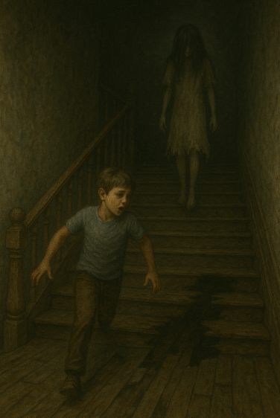
He kept running until he suddenly fell—down, down into darkness—then hit soft ground. He opened his eyes. He was outside. The house was gone. Just trees and stars above. He rode home as fast as he could and never looked back. At home, he found dust in his shoes and something strange in his pocket: an old photo of the house, and the girl… smiling, with her hand reaching out from the picture. That night, the lights flickered, and the photo slid out of his drawer by itself, now showing him standing next to the girl, her hand on his shoulder. He dropped it in fear. The mirror cracked. Then came three slow knocks at the window. Outside, in the dark, floated the girl. Her mouth didn’t move, but her words echoed in his mind: “You left me. Come back.” That night, cold fingers rested on his arm in bed. In the morning, dusty fingerprints were on the wall. They came back every night, more of them. His books fell. Whispers came from the closet. Then the photo returned, warm and ticking like a clock. On its back were scratched words: “Time is almost up.” The window flew open, and the girl came out of the photo—bending, floating, crawling. Behind her came pale figures, broken people with hollow eyes and twisted necks, all whispering, “Come back…” Ravi froze in fear. The room melted away. He was back in the hallway of the house. The front door was gone. The whispers grew louder: “You belong here now.” The hallway stretched forever, lined with doors half-open, each whispering something different—crying, giggling, screaming. He chose the quietest one and entered. Inside stood a tall cracked mirror. He saw himself—but the reflection smiled without him. It raised a hand and pointed behind him. The girl was there, her eyes sad, her voice soft: “Please… help us. The house feeds on fear. If you're scared, it grows stronger.” Ravi was frozen, but he didn’t run. She touched his hand. The whispers paused. The mirror cracked and shattered. And something stepped out—not a ghost, not a human, but the House itself—tall, twisted, with too many eyes and mouths made of doors and windows. It growled. “It knows you’re not afraid yet,” the girl whispered. “That’s why it’s angry.” Ravi looked into its eyes and said, “I’m not scared of you anymore.” The hallway shook. The creature screamed.
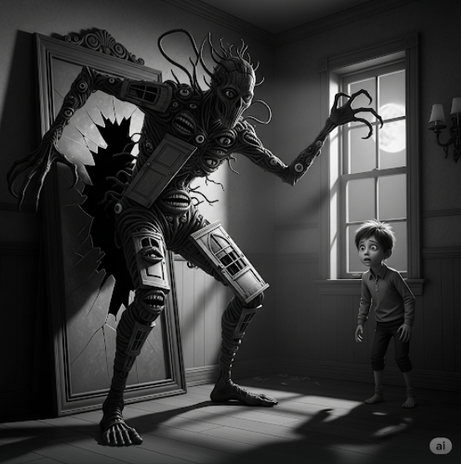
But Ravi stood still. The air around him grew still. Then something changed. The creature's scream echoed through the house, but Ravi felt no fear. Instead, he focused on the girl’s eyes, seeing the sadness, the pleading, the decades of suffering that had trapped her here. The house trembled, its walls bending and twisting, trying to smother him with its dark, suffocating weight. But Ravi stood firm, his hands trembling slightly, his breath shallow but steady. The girl’s whisper came again, softer now. “The house is alive. It feeds on those who fear it. But if you stop fearing, if you don’t let it control you, it can’t hold you… or anyone else.” As her words settled into his mind, Ravi understood. The house didn’t just want to trap souls. It thrived on fear. And as long as he could hold onto his courage, it would lose its power. But just as he began to breathe more easily, the air grew colder. He glanced around. The creature—no longer a thing of twisted doors and windows—was gone. But the house was far from empty. Shadowy figures stirred, gathering around him, filling every doorway and darkened corner. The whispers started again, this time in a chorus of voices, all pleading, all demanding his fear. "We are waiting… we are hungry… come back…". Ravi swallowed hard. He had to act fast. He couldn’t stay here forever. His eyes flickered to the broken mirror behind him. It wasn’t just a mirror; it was a doorway. A way out. The girl appeared next to him, her hand trembling. "The house doesn't let go easily. But you… you have the strength to destroy it. You have to break the mirror." Ravi stepped forward, feeling the weight of the eyes around him, their endless, soulless stares crawling up his spine. The whispers turned to growls, to shrieks, as the shadows pressed closer, a suffocating swarm. He reached out, gripping the sharp edge of the mirror. The glass was ice cold, like touching the heart of the storm. The house howled, the walls shaking violently. "No!" it screamed. "You are mine!" Ravi swung the mirror with all his might, shattering it into a thousand shards. The instant the glass broke, the world around him splintered. The shadows screamed, the walls buckled, and the ground beneath him cracked open. The house groaned in agony as it began to collapse, the very air suffocating with its rage. But the girl smiled, her form fading as the house crumbled. "Thank you," she whispered, her voice distant, as if she were already slipping away. "You freed us." The darkness twisted into itself, and everything disappeared. The ground fell away, and Ravi was once again surrounded by the tall, dark trees of the forest. The house, gone. The whispers, silent. Only the wind, soft and gentle, caressed his face. But as he turned to leave, something caught his eye—a faint shape in the distance. His heart froze. At the far end of the path, there, standing at the edge of the woods, was the house. Whole. Intact. Waiting for him. Ravi’s pulse quickened. He had escaped once, but it wasn’t over. The house had let him go, but it would always be hungry for more. And it knew—just as he did—that fear wasn’t gone. It never truly was. It would wait. Forever. And soon, it would call again. As Ravi stood frozen, staring at the house in the distance, the air around him grew heavy once more. The trees that had once felt comforting now seemed to close in on him, their long limbs like fingers, reaching out to drag him back. The ground beneath his feet seemed to tremble, and for a moment, he thought he heard the distant sound of something—someone—whispering his name. "Ravi…" the voice hissed, low and cold, like the rustling of dry leaves. His skin crawled. He didn’t want to turn around, but the whisper grew louder, more insistent. "Ravi, come back… come back home." He clenched his fists, his nails digging into his palms. His eyes locked onto the house, the windows now dark, like hollow eyes staring at him, waiting. He knew what it wanted. It wanted him to come back. It wanted him to feel that familiar terror again. But Ravi stood tall, his heart pounding in his chest. He had faced it once before, and he wouldn’t let it take him again. He took a step back, his feet shaking, but determination steeling his resolve. “I won’t go back to you.” The wind picked up, howling, as if the very earth itself were protesting his defiance. The ground seemed to crack beneath his feet, the forest around him shaking as the house in the distance seemed to pulse, like a living, breathing entity. Its doors creaked open, an invitation—no, a command. “Ravi…” the voice called again, closer this time. He spun around, his eyes scanning the shadowy trees. From between the twisted branches, something moved. It was tall and hunched, its shape barely visible, but unmistakable. A figure, pale as death, its eyes wide and empty, its mouth gaping. The figure stepped forward, revealing its distorted face, half-rotted, half-human. The girl—no, it wasn’t her anymore. The twisted, hollow thing that had once been the girl floated toward him, her body hovering inches above the ground. Her long hair floated around her like a veil, and her eyes… her eyes were black as night, empty pits that seemed to suck in all light. Help us,” she whispered, her voice splitting and echoing in his mind, all the while inching closer. “Help us all.” Ravi stumbled back, terror rising in his throat. The ground beneath him cracked, and through the fissures, he saw more figures emerging—twisted souls, their bodies half-decomposed, eyes empty and lost. The house had unleashed them all. The very spirits of those it had consumed, trapped here for eternity. Each of them reached out, their hands skeletal, their voices a chorus of agony. “We need you…” they whispered, “We need your fear.” Ravi’s breath quickened. He had to act. He had to leave. But as he turned to run, the forest itself seemed to close in on him, the trees moving, their branches twisting, trapping him in place. He was stuck, caught between the thing that had once been a girl and the nightmare it had become. “You cannot escape, Ravi…” the girl’s voice came again, but this time it was not just her—it was the house itself speaking through her. “You are part of this now. You have always been part of this.” Ravi’s mind raced. He knew there was no way out unless he confronted it again, unless he broke the curse for good. But how? The house had already tried to swallow him whole. Would breaking the mirror again work? No… it couldn’t be that simple. A scream ripped through his thoughts, one that wasn't his own. He spun, his heart hammering in his chest. A shadow passed in the corner of his eye—a figure, running toward him from the house. He was too late. It wasn’t just the house calling him now. It was pulling in anyone who dared to wander too close. The whispers filled his ears, growing louder, drowning out his thoughts. And then, in the distance, he saw something—someone—a silhouette standing at the door of the house. Someone was inside, looking out at him. It wasn’t a face he recognized, but it was so familiar, a part of him deep inside he couldn’t ignore. A familiar face, beckoning him forward. The whispering grew even louder. The house wasn’t just trying to take him—it was calling to something inside him, something buried beneath the years of pain, of fear, of loss. “I am not afraid,” Ravi told himself, but the words felt hollow as they left his lips. The house knew. It always knew. And now, the question wasn’t if it could take him, but how long he could fight it. And the house waited.

5

Eyes That Eat Universes
In a quiet old town called Darkwood, a boy named Aarav walked alone on the stone streets at night. The street was empty, and his shoes made a loud sound on the stones. Aarav had black messy hair and dark eyes that looked sad but strong. His town was once famous for its silver mines and wise teachers, but now it was broken and poor because of the cruel king who burned all books and stopped people from learning the truth. Aarav carried a small old book with a black cover. It had strange drawings and secret words written by his grandfather who disappeared many years ago. That night, Aarav walked to the East Gate where scary wolf statues stood with their mouths open. He went into the Icarion Forest, a place so dark and silent that even brave soldiers were never seen again after going in.

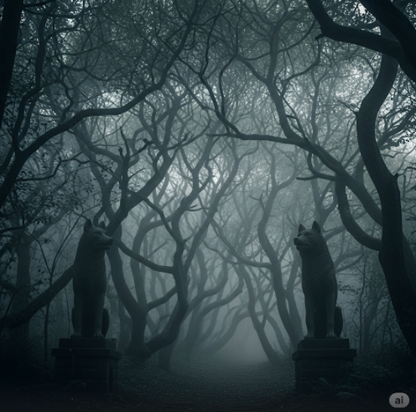
Trees scratched his skin as he walked, and shadows moved under the moonlight. Aarav read words from his book that could call the Spirit of Sorrows, a ghost who knew all secrets. Suddenly the ground shook, and a ghost appeared wearing silver robes covered in glowing symbols. Its voice was like many people crying at the same time. It told Aarav that his family was not only teachers but also magic users who had promised to protect a deep darkness under Darkwood. The ghost showed him a vision of a huge black stone underground, glowing with gold lines, guarded by a giant monster with wings dripping black liquid and eyes shining like the moon. Aarav felt scared and asked the ghost what to do. It said he must give up his favourite memory to enter that place safely. Aarav thought about his mother singing to him every night. With tears, he let the ghost take that memory away forever. His mother’s face disappeared from his mind. The ghost opened a dark doorway with blue lights on it. Aarav stepped through and felt hot air all around him. The walls inside had pictures of crying angels and snakes with crowns. Aarav kept going deeper and saw scary rooms with babies crying without eyes, skeleton kings sitting on thrones made of bones, and tables with hearts beating on them even though their owners were dead. Finally, he reached the black stone. The monster guarding it spread its wings and screamed so loudly that his bones shook. Aarav said special words from his book, and black chains came out of the stone and tied the monster down forever. On top of the stone was a small glass bottle with blue glowing smoke inside. It was called Lumina, which could bring back lost languages and forgotten stories. As he touched it, the ground shook and the ghost appeared again, its clothes burning with blue flames. It told Aarav that by taking Lumina he had woken up a sleeping god under Darkwood, a god that controlled life and death. The ghost said he had two choices. He could give Lumina to the god and be eaten, or drink Lumina and become a powerful spirit forever hungry for secrets. Aarav cried because he only wanted to help his town. But he drank Lumina. His body turned into bright light, and his mind filled with every secret in the world. Aarav became a glowing spirit who could walk between worlds, looking for all truths and keeping them forever. He was no longer human or god, but something in between. People called him the Endless Seeker, who roamed the dark halls of time, never stopping, never forgetting.
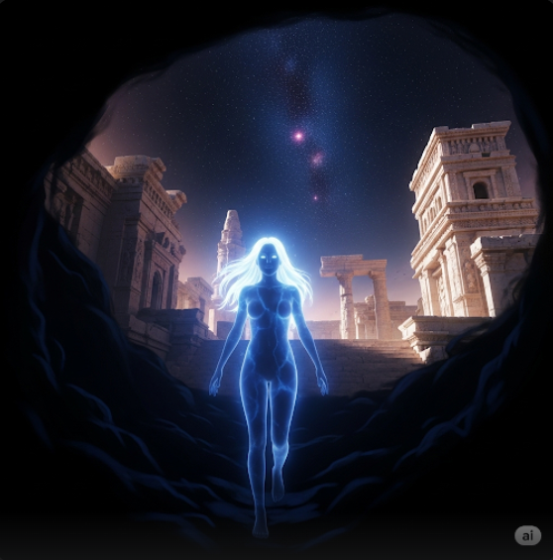
As he entered the city, he saw a glowing spirit girl walking out of a dark cave. Her body was made of soft blue light, and her long hair floated around her like shining threads. Her eyes were calm and full of secrets of the universe. Aarav felt his light become warmer when he saw her. The girl smiled softly and said, “Welcome, Endless Seeker. I have been waiting for you.” Aarav asked, “Who are you? Why are you here alone in this silent place?” She replied, “I am Neyra, the Keeper of Forgotten Worlds. I protect the memories of all places that no longer exist. When planets are destroyed or people vanish forever, I keep their stories safe.” Aarav felt respect for her because he knew how important memories were. He asked, “Why were you waiting for me, Neyra?” She looked up at the stars and said, “Because a great darkness is coming. Even you, the Endless Seeker, cannot fight it alone. This darkness eats entire universes and leaves nothing behind. You and I must join our powers to stop it.” Aarav felt scared for the first time since he became a spirit. But when he looked into Neyra’s eyes, he felt strong again. He said, “Then let us stand together. I will never let darkness destroy everything.” Neyra smiled brighter, and together they floated up into space, holding each other’s light. They looked like two small suns flying side by side into the dark silent universe, ready to fight the darkness that threatened every world.
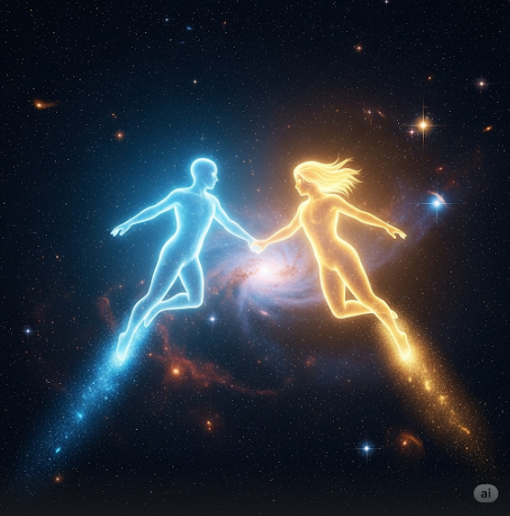
But as soon as Neyra said “Forever,” the space around them suddenly turned silent and cold. The stars stopped twinkling. The bright colours of the universe faded into dull grey. Aarav looked around, confused. “Neyra… what is happening?” he asked, but when he turned to look at her, his golden light flickered in fear. Neyra’s glowing blue face had turned pale like cold ice, her eyes dark and empty like black holes. She was not smiling anymore. Her mouth stretched open wider and wider until it almost reached her ears, and her eyes rolled back, showing only white. Aarav felt his soul tremble with terror. He whispered, “Neyra… what are you…” but before he could finish, her long hair reached out like black tentacles and wrapped tightly around his body. Her voice changed into a deep echoing growl. “You fool… did you really think I was the Keeper of Forgotten Worlds? I am the Devourer’s Shadow, sent to trick you.” Aarav felt himself being pulled closer to her horrible face. Her mouth opened even wider, and inside was not a tongue, but hundreds of small glowing blue eyes staring at him. Aarav screamed in fear. He tried to shine his golden light brighter, but Neyra’s hair-tentacles squeezed him harder, draining his energy. She whispered in her growling voice, “Your light will feed me. And then I will eat every world you saved. And finally, I will eat you.” Aarav felt tears fall from his glowing eyes. He remembered when he was a boy, holding his mother’s hand, wishing to become someone strong and good. Now, trapped in the hands of this horrifying creature, he felt his hope melting away like ice under black fire. But somewhere deep inside his soul, a small golden spark still burned… a spark that refused to die. The small golden spark inside Aarav’s soul burned brighter as he remembered every world he had saved, every person who smiled because of his light. He clenched his fists and screamed, “I WILL NOT LET YOU WIN!” His golden glow flared up, pushing back Neyra’s hair-tentacles slightly. But Neyra’s face twisted into a monstrous grin, her mouth stretching so wide it split her cheeks, revealing black rotting flesh underneath the blue light. “You think your little spark can stop me?” she growled, her hundreds of mouth-eyes blinking rapidly, oozing blue tears that sizzled like acid in space. Suddenly, Aarav felt his mind being pulled into her. Everything around him turned pitch black. He opened his eyes and saw himself standing in his old house in Darkwood. His mother stood in front of him, humming a lullaby, but when she turned around, her eyes were missing, leaving two dark bloody holes dripping onto her white sari. She whispered, “Why did you leave me alone, Aarav?” Aarav screamed and backed away, shaking his head. “This isn’t real! THIS ISN’T REAL!” His mother’s head twisted upside down with a loud crack as she crawled towards him on her hands and feet like a broken insect. Aarav closed his eyes tightly, feeling his golden light flicker weaker. Neyra’s voice echoed through the darkness. “You cannot escape your fears, little Seeker. I will feed on them until nothing remains.” Aarav felt the cold darkness tightening around his soul. His golden light almost vanished completely. But then… he remembered the people on the dark planet who smiled when the sunlight touched their faces after so many years. He remembered their tears of happiness. He remembered that he existed not for himself, but for them. His golden light suddenly burst out from his chest like a star exploding. The darkness cracked around him. Neyra’s scream filled the universe as her illusions broke apart. Aarav opened his glowing eyes, now burning like two small suns, and shouted, “YOU ARE NOT NEYRA. YOU ARE NOTHING BUT A SHADOW!” The real space reappeared around him. Neyra’s monstrous true form floated in front of him – a giant creature with a thousand twisting arms, long dark claws, and a face with no features except a gaping mouth stretching from forehead to chin, filled with sharp black teeth. Aarav clenched the golden staff tightly in his hand. He could feel the voices of every world he saved singing inside him, giving him strength. He said in a calm, deadly voice, “For them… I will destroy you.” The creature roared so loudly that dead planets shook in the silent darkness as it charged towards him with all its arms outstretched.
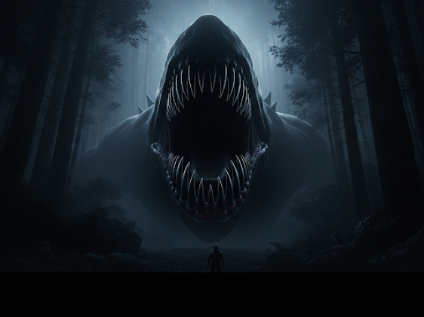
The creature’s thousand clawed arms rushed towards Aarav like a black tidal wave, each claw as long as a sword and dripping dark liquid that hissed like acid in space. Aarav held the golden staff in front of him, feeling its warmth burning brighter as the monster came closer. The voices of the people he had saved whispered in his ears, “We are with you… fight…” The creature roared, opening its giant mouth even wider. Inside, there were rows and rows of spinning black teeth, grinding against each other like a meat grinder. Aarav felt fear crawling into his heart, but he clenched his fists tighter around the staff and shouted, “I WILL NOT LET YOU HURT ANYONE EVER AGAIN!” His golden light burst out, and the staff turned into a long glowing spear. He flew straight towards the creature’s mouth. The monster laughed, its voice shaking his soul, “COME INTO ME, LITTLE LIGHT!” As he entered its mouth, darkness swallowed him completely. He felt the sharp teeth cut into his glowing body, tearing his light apart. Aarav screamed in pain. He felt himself becoming weaker as the darkness ate his hope. Inside the mouth, he saw thousands of souls floating around him, crying silently. Their eyes were empty, and their bodies were half-eaten shadows. They reached their hands out to him, whispering, “Help… please… help us…” Aarav’s tears fell into the darkness, glowing like tiny golden diamonds. He whispered, “I’m sorry I couldn’t save you…” But suddenly, he felt a soft warm hand touch his shoulder. He turned and saw Neyra – not the monster, but her real spirit, glowing softly with blue light. Her eyes were gentle and sad. “Aarav,” she whispered, “you can still save them. Do not give up.” Aarav felt his golden light growing stronger again. He realised the real Neyra was trapped inside the creature too, hidden among the lost souls. He grabbed her hand tightly and shouted, “I WILL SAVE ALL OF YOU!” His spear glowed so bright that the darkness cracked apart. The creature screamed, its voice filled with pain and anger. Aarav spun his spear in a huge circle, sending out waves of golden light that cut through the monster’s dark flesh. The souls trapped inside started glowing again as his light touched them. The creature roared, trying to close its mouth, but Aarav flew deeper inside, straight to its heart. There, in the centre of its chest, he saw a huge black crystal pulsing with dark energy. He pointed his spear at it and whispered, “For everyone you have eaten… for everyone you have hurt… this ends NOW.” He stabbed the spear deep into the crystal. The crystal cracked loudly, black lightning shooting out in every direction. The creature screamed one last time, its thousand arms writhing and breaking apart into ash. The dark flesh around him started melting into shadows. Aarav held Neyra close as the monster’s body exploded into tiny black dust, disappearing forever into the silent space.
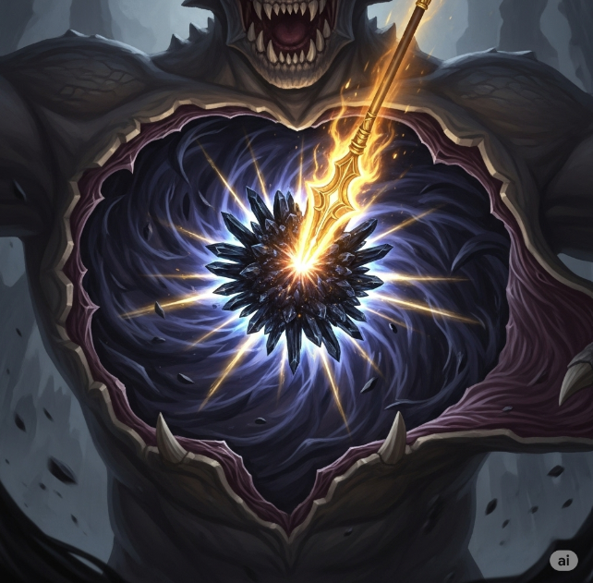
As the last specks of black dust floated away into the endless darkness, silence fell across the universe. Aarav floated there, holding Neyra close to him. Her blue light was flickering weakly, like a candle about to go out. “Neyra…” he whispered, his golden tears falling onto her face, “please… don’t leave me now.” She opened her eyes slowly. Her once bright blue glow was now pale and thin, and her voice was trembling. “Aarav… you destroyed the Devourer’s Shadow… but…” Her voice cracked as a deep rumble shook the silent space around them. Aarav felt cold fear in his heart as he turned to look behind him. The black dust that was floating in the air was now spinning faster and faster, forming a huge swirling black hole. From its centre, a shape started to appear. At first it was only a dark blur, but then it grew taller and taller, its head rising higher than the tallest mountains. Its body was like a twisted mix of bones, shadows, and long thin arms with claws sharper than blades. Its face had no eyes, no nose, just a wide mouth that stretched across its entire head, filled with crooked yellow teeth. As it breathed, the entire space around them turned cold and silent. Aarav felt his golden light flicker. This creature was far bigger than anything he had ever seen. Neyra coughed weakly, glowing even dimmer. She whispered, “That… that is the True Devourer… the Shadow was only its child…” Aarav felt his chest tighten with fear. The creature opened its giant mouth, and from deep inside came a horrible sound – not a roar, not a scream, but a deep endless laugh, echoing through space like a million souls crying together. Aarav held Neyra tighter, feeling her fading in his arms. “Stay with me, Neyra,” he whispered with tears falling, “I can’t do this without you…” The creature’s laugh grew louder. It spoke in a voice so deep it shook every star in the sky. “Little light… little shadow… you think you can fight me? I am the Eater of Realities… I consumed gods before your universe was born… and now… I will consume you…” It raised one of its giant arms, each finger long as a mountain, and swung it down towards Aarav and Neyra. Aarav screamed as the giant claw came closer, darker than death itself. He closed his eyes tightly, trying to protect Neyra in his arms. The giant claw came down with the force of a collapsing planet. Aarav closed his eyes, bracing for the end, but at the last moment, his golden light burst out like a shield around him and Neyra. The claw smashed into his light, shaking the universe with a loud booming crack. Aarav screamed in pain as he felt his golden shield breaking apart piece by piece under the creature’s strength. The Devourer laughed again, its wide mouth stretching even more as black saliva dripped into space, burning holes through distant stars. “Little Seeker… your light is nothing against me…” it whispered in a voice like a thousand graves opening at once. Aarav felt his shield breaking completely. The claw pushed down, and he felt his glowing bones crack under the pressure. Neyra’s faint blue light flickered weaker and weaker as black dust from the creature’s body surrounded her like poison smoke. “Aarav…” she whispered weakly, “I… I can’t… breathe…” Aarav felt his soul burning with terror. His golden light flickered, turning dimmer like a dying star. The creature lowered its face to look at them closely. Its mouth opened wide, and inside, Aarav saw not just teeth, but thousands of tiny twisted hands reaching out, grabbing each other, clawing desperately to escape. Each hand had a small glowing eye in its palm, and every eye was staring directly at him. Aarav screamed in fear. He felt his mind breaking as those eyes stared into him, reading every secret he ever had. The Devourer whispered, “Let me eat you… let me keep you inside me… forever…” Its long tongue, covered in black spikes, slowly slithered out, wrapping around Aarav’s waist and pulling him closer to the mouth filled with screaming hands. Aarav cried out, holding Neyra tightly. He felt her slipping away from his arms as her light grew fainter and fainter. “No… NO!” he screamed, his golden tears floating into space like tiny dying stars. The tongue pulled him closer, and he felt its spikes tearing into his glowing body, draining his strength. The creature’s breath smelled like rotting corpses and burnt bones. Aarav gagged, feeling his soul tremble with pure horror. He closed his eyes tightly and whispered, “Please… someone… help me…” But in the silent darkness, no one answered. Only the Devourer’s horrible laugh echoed around him as its mouth opened wider, ready to swallow him and Neyra whole.
The Devourer’s mouth opened wider than the sky itself as it pulled Aarav and Neyra closer with its spiked black tongue. Aarav’s golden light flickered weaker under the creature’s poison touch. He felt his soul shaking with fear as he saw the thousands of tiny hands with glowing eyes writhing inside its mouth, each eye staring at him with hunger and hate. The creature whispered in a voice that shook his bones, “Come inside… let me swallow your light… let me keep you forever in my endless darkness…” Aarav tried to fight back. He pushed his golden light outwards, but it only made the Devourer laugh louder. Its mouth stretched wider, cracking its jaw bones with loud snapping sounds as its hundreds of teeth turned like grinding wheels, ready to tear him apart. ] Suddenly, Aarav felt Neyra’s faint blue hand touch his chest. He looked down and saw her glowing eyes staring into his weakly. “Aarav…” she whispered softly, her voice trembling, “use me…” Aarav shook his head with tears falling. “No… Neyra… if I use your power you will…” But Neyra smiled sadly. “It’s okay… I am only a Keeper because people’s memories live inside me. If I become one with you, I will live forever inside your soul… please… end this…” Her blue light wrapped around his golden light, fusing into one bright swirling glow. Aarav felt her memories, her sadness, her hope, and her love for all forgotten worlds flow into him. His chest burned with a new power – a light that was no longer only gold, but blue and gold together, swirling like two galaxies combined. The Devourer roared in anger. “WHAT IS THIS? YOU THINK THIS WILL STOP ME?” It pulled them closer, but Aarav opened his glowing eyes, now filled with swirling blue and gold flames. He whispered, “No… but it will end you…” Aarav raised the golden staff high. It transformed into a massive glowing sword with ancient runes shining down its blade. He felt Neyra’s voice inside his mind, whispering, “For all worlds lost… and for those still living… strike now…” Aarav screamed with all his soul as he swung the giant glowing sword down. The blade cut through the Devourer’s spiked tongue, slicing it in half. The creature howled in rage, shaking the universe. Its blood poured out into space like endless rivers of black ink, burning stars wherever it touched.
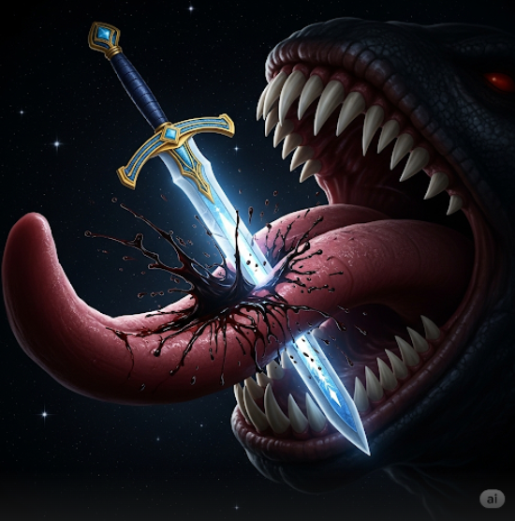
The creature roared so loudly that distant galaxies trembled. It swung its huge claw to crush Aarav, but he flew up faster than lightning, holding the sword tightly. With a final scream, he stabbed the sword straight into the middle of the Devourer’s forehead. The blade sank deep into its shadowy skull, and blue-gold light exploded out from every crack in its body. The creature’s scream turned into a choking gurgle as its entire form started breaking apart into dust. Aarav pulled the sword out and floated back, holding Neyra’s fading spirit close to his chest. The Devourer’s body crumbled away into a giant black cloud of ashes, disappearing forever into the silent void. As the darkness faded, bright stars filled the space once again. Aarav floated there, tired and shaking, feeling Neyra’s faint voice in his soul whispering softly, “Thank you, Aarav… my Endless Seeker…” Her blue light fused completely into his golden glow, leaving only him floating alone in the silent starry universe, his eyes burning softly with blue and gold flames. But as he looked out at the endless space before him, he saw something that made his soul freeze with horror. Far away, beyond the dying black dust, there was a giant closed eye… an eye so big it covered the entire sky. It opened slowly, revealing a deep red pupil that glowed like burning blood. The eye blinked once, and in that single blink, thousands of stars disappeared into darkness. Aarav felt a cold chill crawl down his glowing spine as he realised – the Devourer was only a servant. Something far older and far darker was watching him now. Aarav floated silently in space staring at the giant blood-red eye that blinked in the darkness beyond the stars its pupil so deep it looked like an endless abyss his golden and blue light flickered softly as Neyra’s voice faded completely leaving only her warm memory the eye blinked again and a deep ancient voice echoed shaking every star every planet every atom “Little Seeker you destroyed my servant but you only delayed the end I am the Beginning and the End I am the Sleeper Between Universes I am what your gods fear to name” Aarav felt fear crawl through his soul but he clenched his fists tighter around the golden staff holding every memory of Neyra and the worlds he saved his glowing eyes burned as he shouted into the cold silent darkness “I don’t care what you are as long as I exist as long as a small light burns in the universe you will never win” the eye narrowed slightly as if amused then closed slowly and disappeared leaving the universe silent and starry again Aarav floated there alone knowing one day the Sleeper would awaken to end everything but until that day came he would keep flying world to world saving every small light because he was no longer just the Endless Seeker he was the final protector of the universe and as long as his soul burned with golden and blue light hope would never die the stars twinkled softly around him as he whispered in the silent cold space “I promise I will never let your darkness win.”

